confirmation of stay

Hereby confirm for the person ......................... having booked a stay at Kebene Lodges & Cottages for the period from
start dates:
end dates:

The residence is located in Mombasa,
Diani Beach, Po Box 462, 80400 in Ukunda
Environment of the airstrip
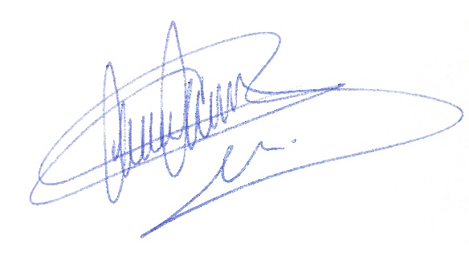
This declared true,
Kebene Lodges & Cottages
Mr Princen Pasci

