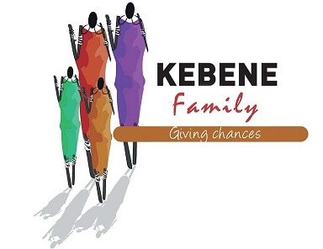
KEBENE DAYCARE

GAMES AND CREATIVITY
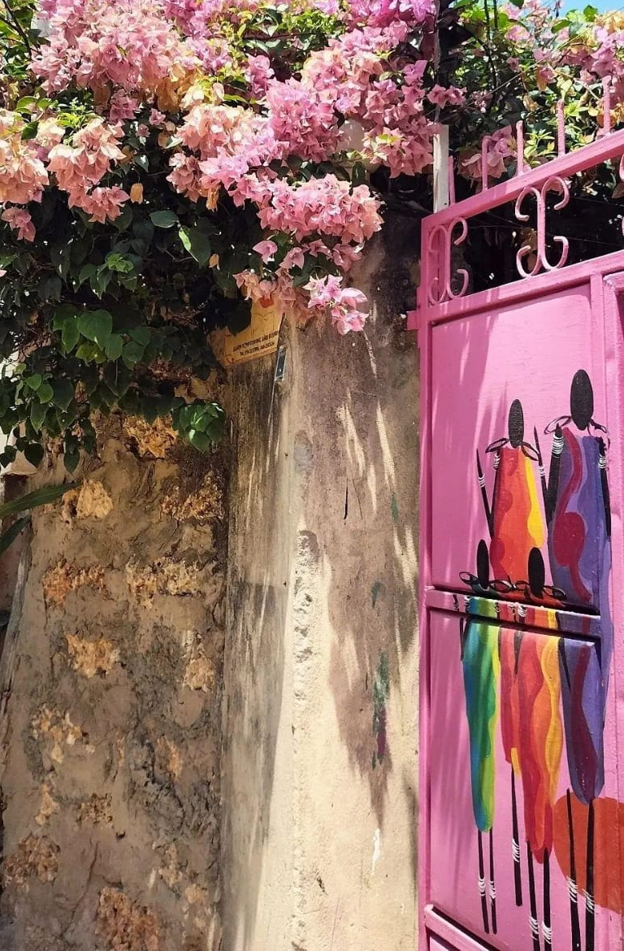

WEEK 2

"A Community in which every child attains the right to survival, protection, development and has the opportunity to participate and achieve his/her fullest potential and atributes to all aspects of their life. "

This guideline is designed for Kebene Daycare, with the intention to provide ideas and suggestions for the Games & Creativity hour. It is not mandatory to follow every activity as it is described. The teacher is free to add, remove or change anything she sees fit, to, adapt to the needs and interests of the children in her classroom. But I hope, it is able to give the teacher some inspiration if she ever is to need it!
With deep love,
Auntie Elisa

PS: For any new volunteer that would like to update this document; add game suggestions or change dynamics, I will send Papa Pasci a copy of this guideline, so he could send it to you for editing, if needed to.

Two groups:
- GROUP 1. WATOTO WADOGO/LITTLE BABYS
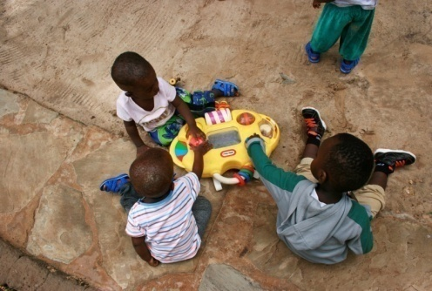
Stimulated by songs, dances and toys
they can explore with.
- Materials: Baby toys & music

- GROUP 2. WATOTO WAKUBWA/BIG BABYS

- WEEK ONE GUIDELINE

Monday. Color day
Tuesday. Nature day
Wednesday. Body parts
Thursday. Number day
Friday. Music day

- DAILY GUIDE LINE

9:30 - 10H. Assembly
10H - 10:30. Porridge
10:30- 11H. Free play
11H.- 11:30. Teaching time*
11:30- 12H. Games and Creativity*
12H- 13H. Lunch time
13H- 16H. Sleep time
* Theme: Topic of the day

- WEEK TWO GUIDELINE

Monday. Shape day
Tuesday. Animal day
Wednesday. Alphabet day
Thursday. Ocean day
Friday. Music day

MONDAY: SHAPE DAY !

1) Shapes and figures in Bingo

Just draw in a piece of paper, for every child, all of the different shapes you have taught (circle, oval, square, rectangle, heart, star, triangle...).
Draw the same shapes on small pieces of paper and put them into a bowl.
The game consists on the teacher taking out of the bowl a different piece of paper, with a different shape every time. The children will have to cross the same shape on their own piece of paper.
When he gets three shapes in a row, he wins!
The prize: The winner gets to be the bingo caller for the next round. Trying to name the shapes as he pulls them out of the bowl is a lesson in itself.

2) Turning shapes into objects!

For this activity you will have to draw a few figures on a white piece of paper for every child. You will give them freedom of creating whatever they can imagine with those shapes!
For example, they can create a head of a person from a circle, a bus from a rectangle... It is a very creative way of practicing shapes and imagination in a fun way!
- Materials:
- White paper
- Colour

3) Making shapes with strings
For this game each child will have its own string. There will be different rounds, with different figures that the children will have to try and recreate.
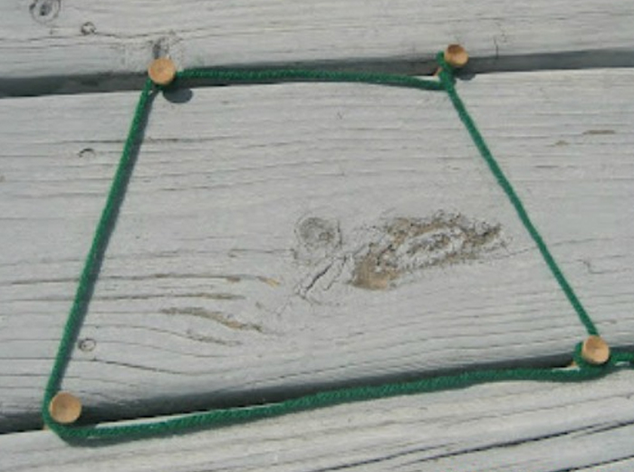
The teacher will be the first to create a shape with the string, and the children will try and do the same as she does.

4) Play dough time!
Let the children experiment with play dough, create different shapes with their own hands. (The teacher will guide them if it is necessary)

5) Chalk games
For this category, the teacher can be creative with the different games she can create with chalk.
She will draw on the ground some shapes.
Game 1. The teacher says a name of a shape and the children will have to run and jump in that shape.
- For example: Circle, and they will have to try and all get inside the circle.
Game 2. The children will have to look for materials from daycare that correspond to the different shapes and put them inside the chalk figures.
- For example: Finding things that are square shaped round the compound.
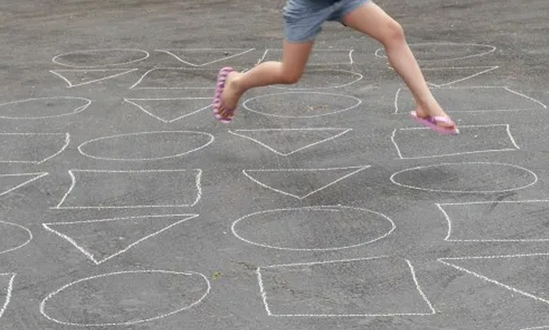

6) Let's use our paint brushes and color papers !
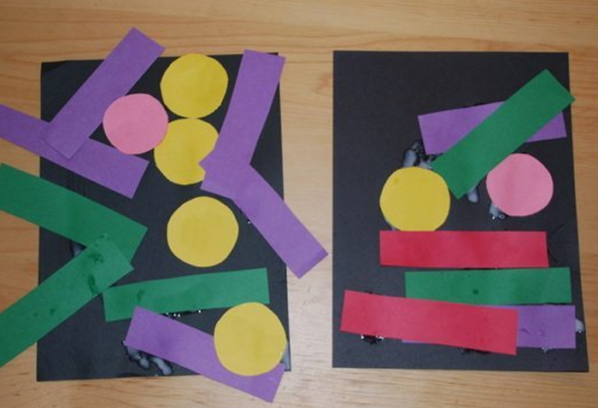
For this activity the teacher will have to be creative and guide the children to make an art piece with different figures and colors! The kids can use paintbrushes, different texture papers...

7) Shape monsters!
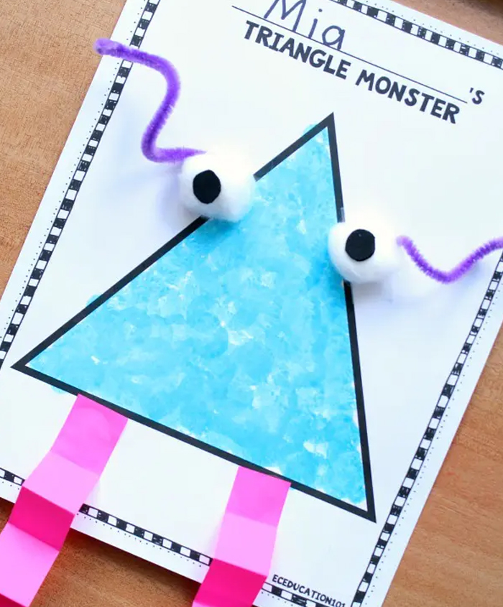

For this game the children will create
different funny monsters, with the materials, colors and shapes.

8) Lets paint some different shaped rocks!
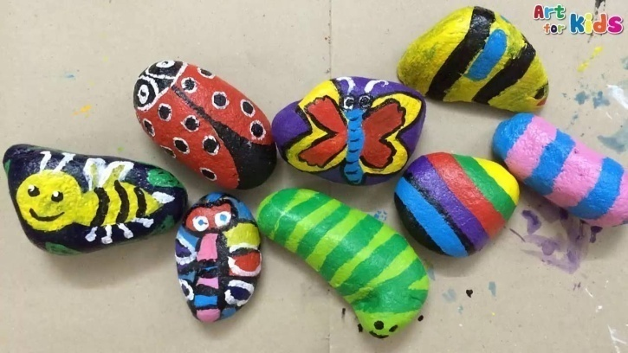
For this activity the children will have to find some rocks (Oval, square, circle, rectangle, triangle...) Then each child will decorate them s they wish.

9) Shaped original plates
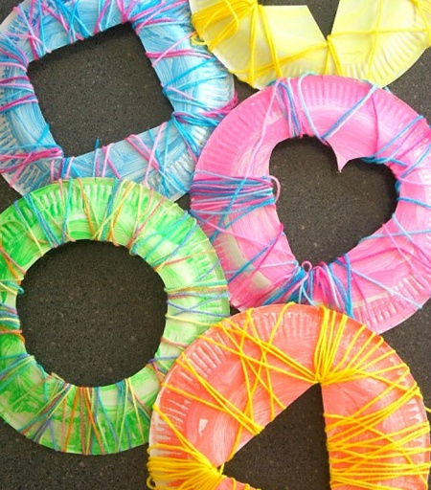
For this game the children will cut with scissors the shape in the middle (It may be difficult for them, but the teacher must guide them closely, it is very good for them to learn to use scissors). after they will paint, and decorate the plates, creating an original art piece

10) Find the hidden shapes
The teacher will hide the shape sheets around daycare. The children will have to find and identify the shape they find. (They will have to go in group, accompanied by the teacher).

TUESDAY: ANIMAL DAY!

1) What am I?
For this game, each child will have to think of different animal.
Then he will have to act like the animal, and the rest of the class will have to try and guess which animal it is.

2) Noah’s Arc
This is a fun animal sound game for children.
You need pieces of paper with animal names written on each. Only two of each animal. You will put all the pieces of paper in bowl or a little box.
After, Each kid will have to pick a piece of paper to see what animal they are, they can't tell their animal to anybody.
They must then walk round and try to find their partner by making the sounds of their particular animal.

3) Steal the lions tail
For this game the class will have to go and play outside and move their body. Each child will have a cloth or a piece of toilet paper stuck in the back of their trousers, hanging out. The children will have to steal the tail of the rest, and try that they don't steal their own.

4) FIND THE ANIMALS!

BEFORE your event— hide several farm animal toys or cards around the event area, yard, etc.

Paint or decorate a box to look like a barn or cage-or use a BASKET.

Before you start, explain to the children that old McDonald’s (or the pet shop or Zoo Keeper’s) animals got out.

The children are to search and collect the toys/cards and RETURN THEM TO THEIR HOME.

5) DOGGIE, DOGGIE, WHERE’S YOUR BONE?

A child is picked to play the part of the dog. He or she sits on a chair with an object under it (to represent the bone) with their back to the group.

While the dog is turned around with his or her eyes closed, someone steals the bone and hide it somewhere on his person.

Then everyone sings: Doggy, Doggy, where’s your bone? Somebody’s stole it from your home. Guess who it might be.

The dog has two chances to guess who took it.

If the dog guesses right, he gets to do it again. If he guesses wrong, then the child who has the bone gets a turn as the dog

6) DRAWING GAME: ANIMAL JUMBLE

Using construction or white paper, ask each child to drawn a different body part of an animal, but to have their animal be a secret. For example, have one child draw the head, another draw the tail, another the legs and so on.

Have the children pick the animal they want to draw.

When they are done have then put the animal together with tape or glue.

Have fun coming up with a name for the animal (monk-dog-lion-potamus...)

7) ANIMAL PARADE

Children form a circle. One person is chosen to be the leader.

The leader calls the name of a child and names an animal.

The child does an imitation on the movements of the animal named.

After everyone has had a chance to imitate an animal, all players form a line for an “Animal Parade” led by the leader. (You can make it more fun, by adding "hats", "tails"... creating costumes with the children, for the parade)

The group moves around the room, each imitating the animal he/she represents. Variations: Play a round with sound imitations only-or a combination of sounds and movements.

8) HELP THE BIRDS-BUILD THEIR NESTS

Lend a helping hand to the birds in your area by supplying them with simple nesting materials, or creating one for them.

Dried grass, short lengths of yarn and string, stuffing from old furniture or feather pillow dryer lint, also hair from your brush.

Hang the bag in a location that the birds can safely access; watch the birds collect-hunt to see if you can find one of “your” nests!
PS: You can also create bird houses for them to stay in.

9) Animal MASKS

This art and craft activity is to let the children become an animal, by creating a mask, made from card stock or paper plates. They will love it!

10) Sleeping Lions
Tell the group of children to lie calmly on the floor of a big room just like the sleeping lions. Instruct your kids to lie down as still as possible.
Any kid who makes a substantial movement, you can get him or her, and mark the kid out.
One who lies still till the end of the game is the winner. It is a great fun animal activities for kids to enjoy.
-Quick tip:
Choose one or two kids from the group as hunters and ask them to make some fun attempts at making the sleeping lions move. (tickling...)

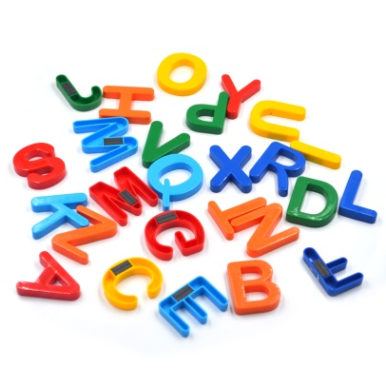
WEDNESDAY: ALPHABET DAY

1) Simply make it a race!

Lay out some letter cards and shout out a letter, have your child run as fast as they can to find it and bring it back to you.

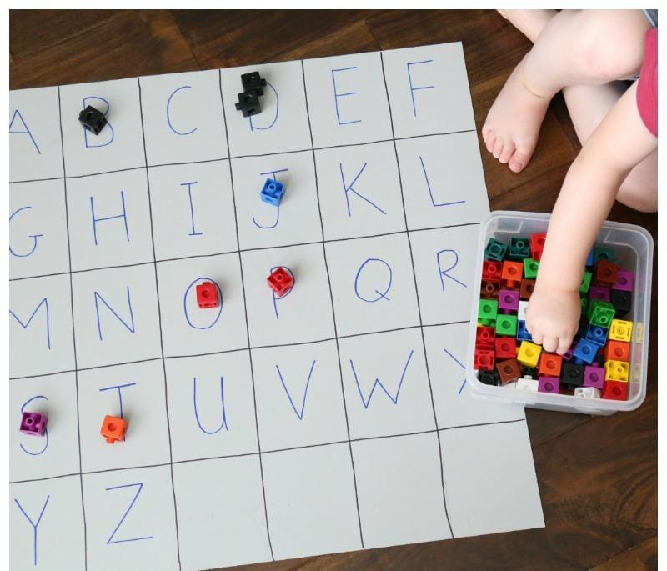
2) Recognize the sound!
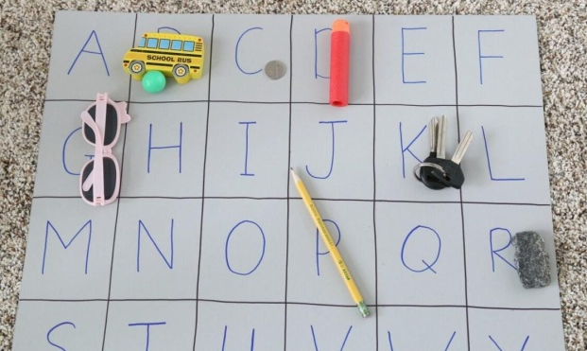
For this game the teacher will need some colored pieces. Then she will say out loud the sound of a letter, and the children will have to try and recognize the letter which she references, while they put the colored piece over It.
It is also possible to add variations to this game, such as: Putting objects that begin with the same sound of a letter, over the letter.

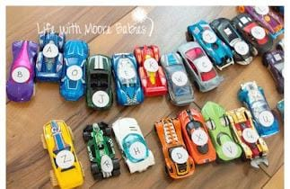
3) Race the letters!!!
This game is incredibly good for letter recognition. The teacher can assign car (With letter on it) to each child. Let's see who the winning letter is!

4) Climb the Word Ladder:

Kids get to “climb” to the top of the ladder as they successfully identify letters and sounds. They don’t need to worry if he they “fall,” they have the opportunity to try again.

5) Make a Letter Game

Letter Formation Activity – Using common materials you can find at daycare, the kids will have a lot of fun forming their letters.

6) Alphabet I Spy

Take the classic and beloved game of “I Spy” and turn it into an alphabet search activity. Brilliant!

"I spy with my little eye, the letter...... B!" So they have to localize it.

7) Letter lacing

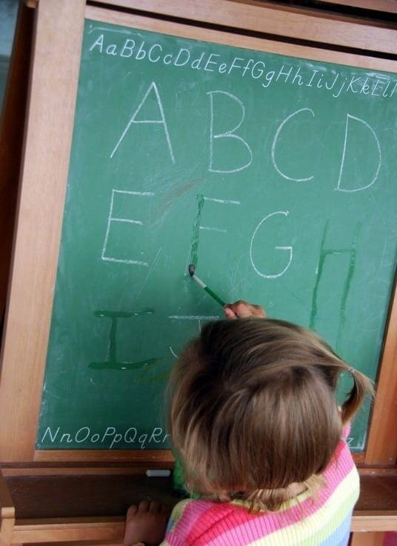
For this game, the children will have to use some cotton string and some paper letters ( They can create them themselves, with the teachers help). They will have to put the letters in order in the string. (Maybe you can hang it in the classroom after)

8) DISAPPEARING CHALK LETTERS
This is a really fun way for kids to work on writing their letters. All you do is write their letters on a chalk board. Then, you give them water and a paint brush; the letters will disappear by tracing them!

9) Puzzles time!

We have lot of puzzles in daycare, we can use some, create puzzle n identify what they see in them (Things with the letter C, D...)

10) Playdough word creators
For this game, the children will become chefs. They will have to bake different letters with their hands!

THURSDAY: OCEAN DAY

Today is excursion to the beach day! Organize the older kids, get some buckets or beach toys, and enjoy!
PS: Remember to talk to the children, about where we're going, what things we can see, what animals there are ...

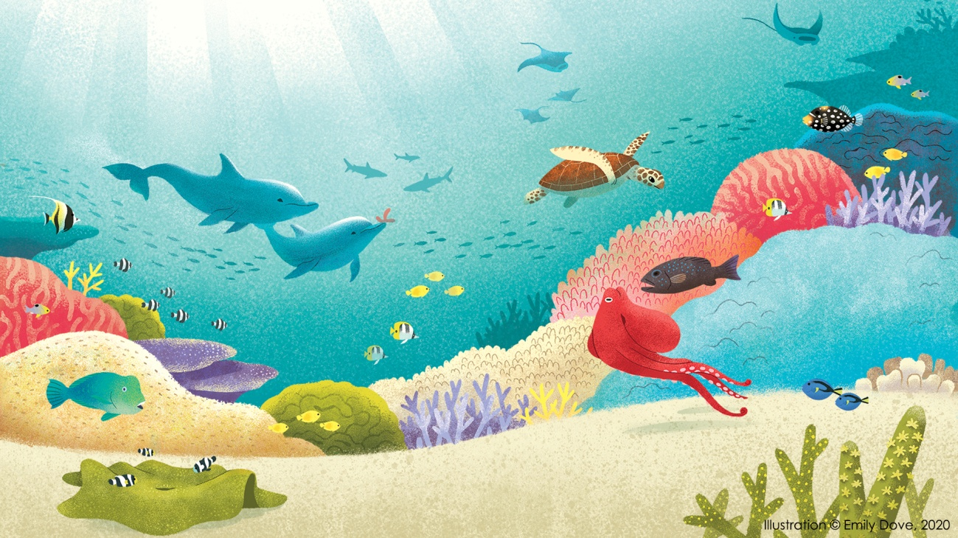

FRIDAY: MUSIC DAY!
This day is a recap day, where we dance and play with music, whilst we revise the lessons of this week! It is a fun and active way of remembering and reinforcing the information we have learnt.
PS: If there are volunteers with laptop, it is possible to connect it to the TV and watch different videos on Youtube (Cocomelon, etc.) or movies.
.

1) Musical masterpiece
Give each student a sheet of paper and color pencils.
Instruct the students to start drawing when you play the music and stop drawing when the music stops.
Leaving the paper and pens at the desk, move to another desk and continue drawing and coloring in that sheet until the music stops again.
Ask them to do so until you tell them to stop.
In the end, they go back to their desks and see the final product.

2) Musical statues... and what else?

Play the music and ask the kids to dance.

When the music stops, the children should freeze like statues.

The kids have to stand like that for a minute or so, and anyone who moves, giggles, or even wobbles when the music is not playing is out.

When the music is back on, they continue dancing.

The last person dancing on at the end is the champion statue!
- After introducing them to musical statues, the teacher can apply the lessons learnt that week:
When the music stops, go and touch color red, touch shape of a circle, touch number 3, touch body part head... !

3) Musical chairs
Set out chairs around the room (one for each player).
Play music and while it is playing, everyone dances around the room.
Remove one chair while everyone is dancing.
Stop the music every now and then and everyone must run and sit on one of the chairs.
Whoever didn’t get to a chair in time is “out”.
Repeat, removing a chair each time until there are two people left and the one who sits on the remaining chair first is the winner.

4) Match the Sounds

For this activity, you will need a variety of handmade or improvised instruments.

The objective is to listen to the music/sounds the teacher makes, and try to find appropriate instruments that match or pair well with the sound.

5) Draw the Music

In this activity children quite literally draw the music as they hear it.

Provide large pieces of paper and pencils or wax crayons and ask your children to draw what they hear.

They could draw:

How the music makes them feel, Wavy lines or zig-zags to represent slow, flowing music or fast, choppy music, the beats they hear (e.g. draw short and long lines for short and long sounds)

6) Hide and Listen

This game is about hearing the volume and making the correct associations (loud means close and soft means far).

With some handmade intruments, and the help of your children, you will be musical guides.

Blindfold your child and hide one object they know about.

Explain that when the instruments play softer he is going further from the object and when it gets louder he is getting closer to it.

6) Musical limbo

Limbo is a game that tests how flexible the body is. Add music, and it becomes all the more fun. In musical limbo, you don’t just walk under the beam. You have to go dancing from under it!

Have two adults hold the beam at a height such that the kids can pass from under it without a lot of effort.

There are two simple rules to this game: the kids have to dance to move, and they should not touch the beam.

Whoever touches the pole or fails to dance while under it is out of the game. After one round, lower the beam a little and repeat the routine.

Do it until there is only one kid left. The kid who manages to last till the end wins!

7) Dance like an animal

Put the chart of animals at a place where all the kids can see it.

You need to tell them how the animal moves, how fast or slow it moves, the sounds it makes, and any other unique traits it has.

For example, a kid who picks a dog has to be on all fours and bark in between while dancing or swaying. A snake has to crawl on the floor and a bird will flap its wings when dancing.

If need be, you could show them a few moves and get a few giggles in return.

Play the music, keep shuffling between genres, from slow to fast and vice versa. Watch the fun!

8) Nature dance/Fashion show
With the creativity of your children, you will make some nature clothes and then do a fashion show with some music over to dance too!

9) Dancing with body parts
For this game, the children will have to follow the director (Which first will be the teacher and after one of the children). If the director dances with his/her hands, only, everybody will have to do the same. (Hands, legs, head, shoulders, feet...)

10) Karaoke
For this activity, the teacher can create a fake microphone and let the children take turns to be the star!

11) Prepare for Family day show!
Tomorrow, Saturday, it is family day, what can be better than creating a special dance, song, or show to surprise everybody? Let's have some fun!

