KEBENE DAYCARE

GAMES AND CREATIVITY
WEEK 1

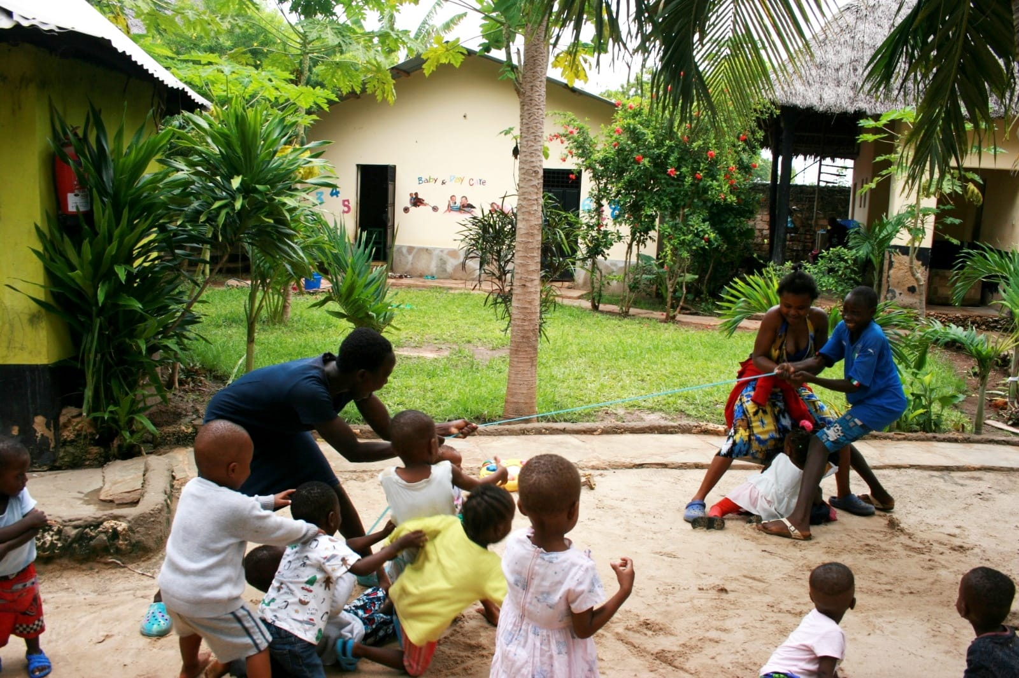

"A Community in which every child attains the right to survival, protection, development and has the opportunity to participate and achieve his/her fullest potential and atributes to all aspects of their life. "

This guideline is designed for Kebene Daycare, with the intention to provide ideas and suggestions for the Games & Creativity hour. It is not mandatory to follow every activity as it is described. The teacher is free to add, remove or change anything she sees fit, to, adapt to the needs and interests of the children in her classroom. But I hope, it is able to give the teacher some inspiration if she ever is to need it!
With deep love,
Autie Elisa

PS: For any new volunteer that would like to update this document; add game suggestions or change dynamics, I will send Papa Pasci a copy of this guideline, so he could send it to you for editing, if needed to.

Two groups:
- GROUP 1. WATOTO WADOGO/LITTLE BABYS
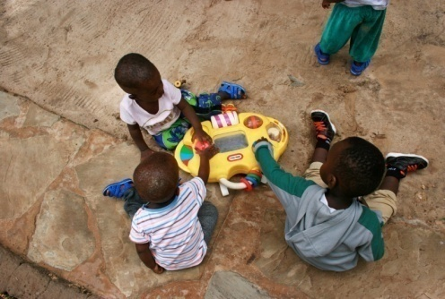
Stimulated by songs, dances and toys
they can explore with.
Materials: Baby toys & music !

- GROUP 2. WATOTO WAKUBWA/BIG BABYS

- WEEK ONE GUIDELINE

Monday. Color day
Tuesday. Nature day
Wednesday. Body parts
Thursday. Number day
Friday. Music day

- DAILY GUIDE LINE

9:30 - 10H. Assembly
10H - 10:30. Porridge
10:30- 11H. Free play
11H.- 11:30. Teaching time*
11:30- 12H. Games and Creativity*
12H- 13H. Lunch time
13H- 16H. Sleep time
* Theme: Topic of the day

- WEEK TWO GUIDELINE

Monday. Shape day
Tuesday. Animal day
Wednesday. Alphabet day
Thursday. Ocean day
Friday. Music day

MONDAY: COLOUR DAY !

1) Run and Sort Colour Game
Have kids grab a pom pom (or coloured figure) and run to the designated coloured bucket. Then ask them to drop their figure in the box for that color, one by one. It's simple and fun, but can be challenging enough for children of different ability levels.
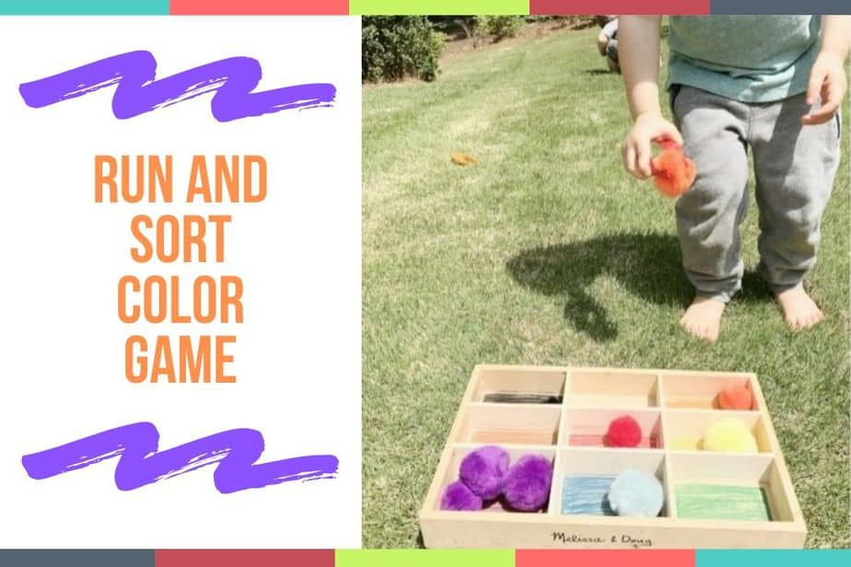

2) Four Corners Preschool Colour Game
First, get some color construction paper and tape it to the floor. Then have each child take a turn standing in one of the four corners or another designated spot. Ask them to close their eyes as you scatter some small objects nearby (pom-poms, counters, puzzle pieces, etc.) The kids then open their eyes and race to find something that's the same color as the tape on the floor.
Materials: Color construction paper
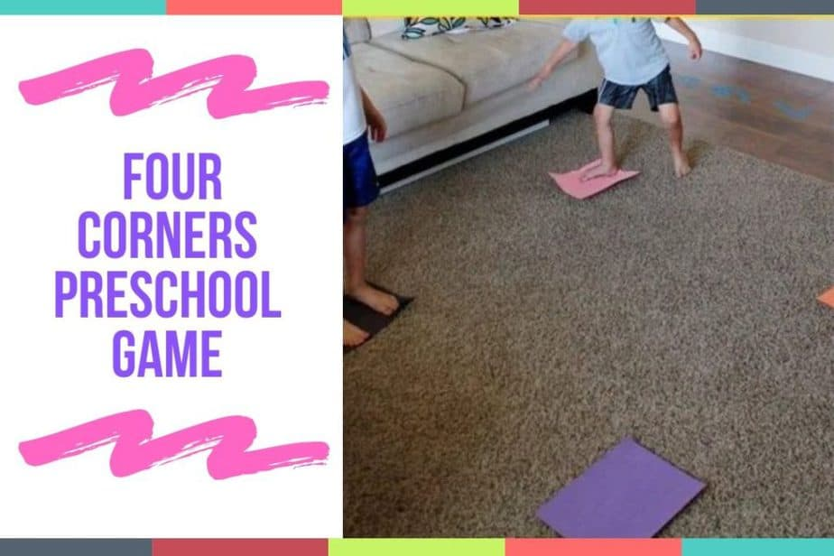

3) I Spy With My Little Eye

Identify objects by colour and add in more details for clues:
“I spy with my little eye... something blue that you wear on your head.”

4) Color Scavenger Hunt at Daycare
Take a crayon of a color of your choice and use it to set off a scavenger around the daycare. How many blue items can you count in class? Did you find any purple items in the playground? This fun color hunt will get kids looking all over for things that match a specific color. Plus, it can be an opportunity to teach them about descriptive words.
- Materials: Daycare items of color

5) Pom pom sort out bottles
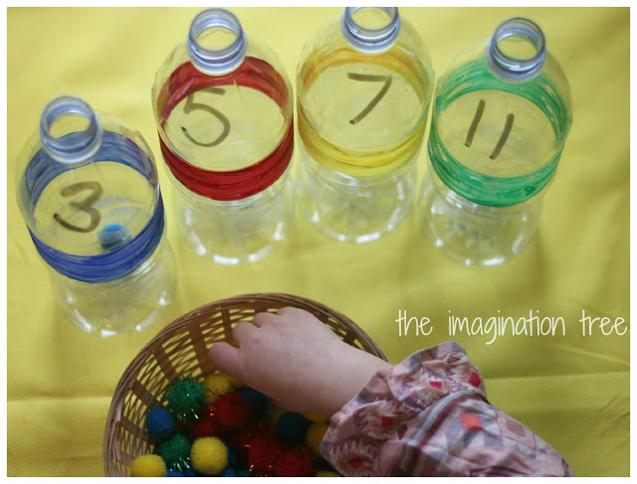

For Daycare we can also use the circle figures with the coloured buckets!

6) Colored pasta necklaces
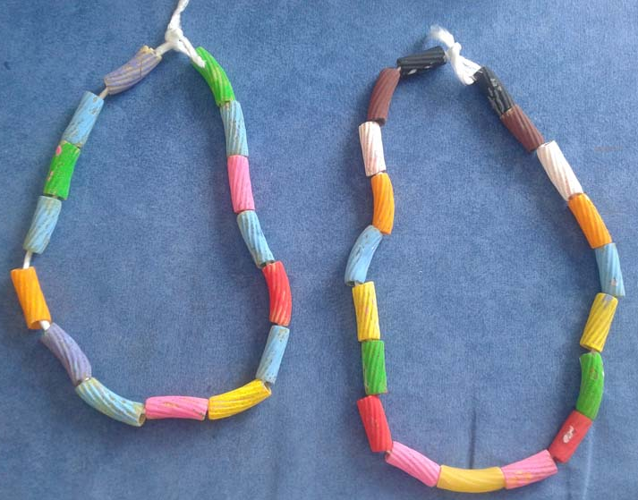
Use paint and some uncooked pasta. Have the students dip the pieces of pasta into the paint and use it to make a picture on a piece of paper. Or consider painting the pasta pieces and then putting them on a ribbon or string and making them into a necklace once the paint is dry.
You can ask for a pattern of the necklace like: Red, blue, green, red, blue, green...

7) Finger painting
Here's an activity that turns into an art project! Pour some paint onto plates and have the children dip their fingers or hand into the paint. Then use their hands as stamps to press onto a white paper, so they can create a picture. Colors are fun, but so are artistic masterpieces.
- Materials:
- Paint
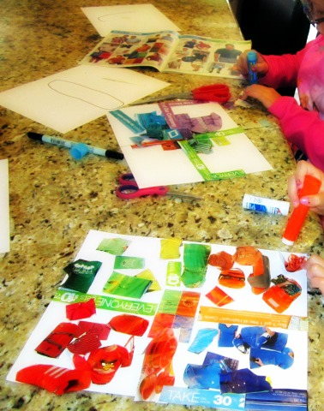
- White paper

8) Colour collage

Make a colour collage by using paper tearings in only one colour. For young toddlers provide the paper tearings, but let older kids find and tear the colour in a magazine or set of coloured papers.

9) Colour pattern construction
Teach kids to follow patterns by drawing or building colour patterns with objects such as blocks.
For younger kids, use only two colours in a pattern and increase it for older kids.

10) Coloured playdough
Let kids play with playdough in various colours.

TUESDAY: NATURE DAY!

1) Bug Hunting

Going outside and searching for bugs and insects can be a thrilling experience for kids. You can take a magnifying glass with you as well as a pen and paper, and encourage the kids to draw what different bugs look like and where they live. You can even continue the research in class after, researching and talking about the bugs they find more interesting.

2) Nature color walk

Head out and take a walk around the daycare. Get the kids to find cool examples of different colors in nature. For example, you could pick specifically colored petals, leaves or stones. When you come back from your walk, challenge the kids to match the colors they have found up with their crayons or other coloring instruments. This is a beautiful way to learn about nature’s vast palette of colors.
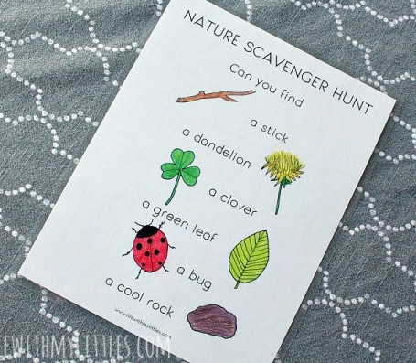

3) Nature Scavenger Hunt

Before you begin, research the types of natural flora and fauna you can find within your local vicinity. Draw up a basic list that won’t be too difficult for your kids to follow.
Now comes the fun part, go out and find the items! Make sure to accompany and supervise your kids at all times, so they don’t become too over-excited and get lost.

4) Nature Yoga

You don’t have to be a yoga expert to enjoy this special nature variation of the classic meditation and exercise technique. Yoga deals with poses primarily as a way of practicing the activity. For this version, all you have to do is pose in the form of some popular nature staples. Challenge your kids to pose like a tree, a frog, flower and anything else nature related. Make sure it’s not too difficult for them to achieve and encourage them all the way. Not only will this be a lot of fun, it’s also a brilliant introduction to keeping healthy and engaging in exercise!

5) Stack the Rocks

The aim of the game is simple, encourage your kids to find a bunch of similarly sized rocks or stones. Now all they have to do is balance them on top of each other without them falling! This is an awesome game to teach kids about balance and shapes, as well as training up their focus and concentration.

6) Nature Painting

Accompany your kids outside to find lots of different items and objects from nature. These can be small sticks, flowers, leaves, stones etc. Once you have found a sufficient amount, take them back inside and turn them into a beautiful nature collage! Encourage your kids to mess with the composition and create unique patterns. Have fun experimenting!
- Materials:
- Items of nature
- White piece of paper/ cardboard

7) Growing seeds

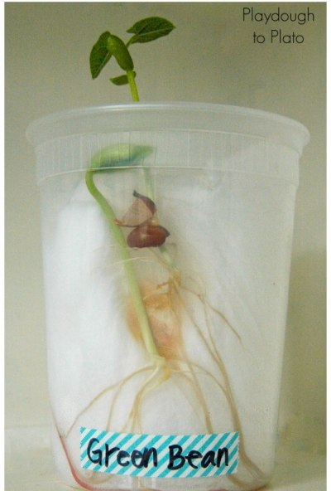
For this activity you can use regular beans for the seeds or any type of seed you choose. It is a good idea that each child plants their own seed in their own container and write their name on it (yogurt can, cup...). Every day they can see how much their plant has grown.
You can also label different containers with the different type of seeds, so the kids can understand the difference between the plants as well.
- Materials:
- Seed
- Cups/ yogurt cans/ water bottle cut in half...
- Cotton

8) Frozen flowers sensory play
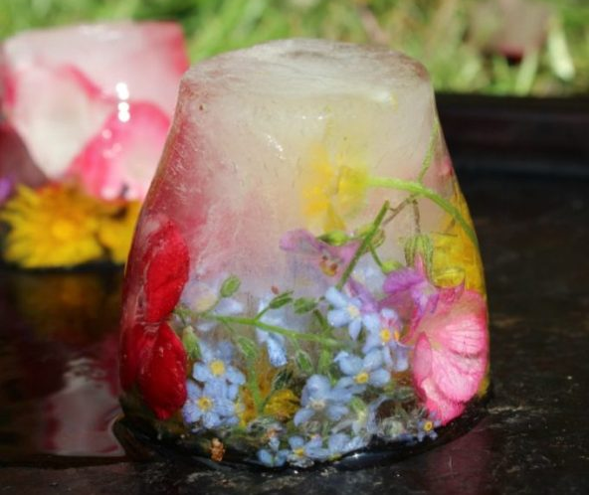
This is probably the easiest activity – just freeze some flowers a day ahead and then let them melt into one pretty yet messy solution in a large tub. Let the children play and explore with the frozen ice.
This is activity has to be taken outside or used in a big bucket.

9) Nature paint brushes
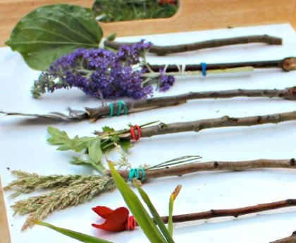
For this activity you can use sticks to create paintbrush handles and all kinds of materials to make the brush ‘hairs’ (Flowers, leafs...)
- Materials:
- LIttle elastic bands for holding the brush to the stick

10) Leaf threading

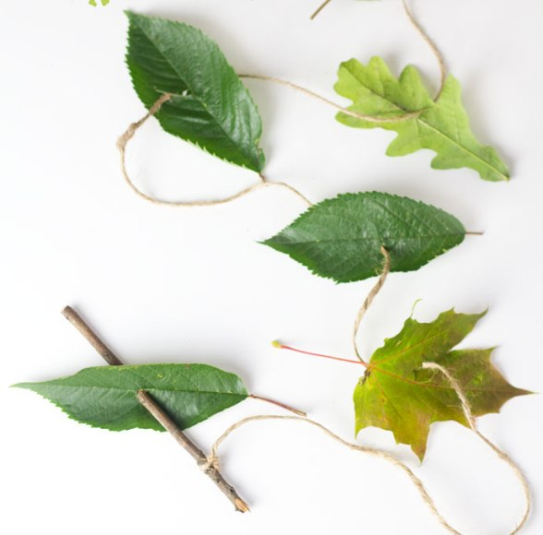
For this activity you can make a leaf necklace or bracelet with leafs. The teacher can make a stick ‘needle’, tie on some ‘thread’ and you’re ready to thread your way through some leaves!
You can make it more interesting if the kids have to have to find different type of leafs, or colours.
- Materials:
- Thread

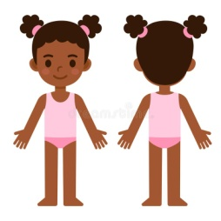
WEDNESDAY: BODY PARTS DAY!

1) Simon says
For this game the teacher becomes the commander of instructions and the children have to follow her orders.
The children must do what the teacher says, but only with ONE condition: If she says ' Teacher says...' before the instruction.
Example: Teacher says... TOUCH YOUR NOSE! = So they all have to touch their nose.
But if the instructor says only: TOUCH YOUR NOSE (Without saying before ' Teacher says...') = So they don't have to touch their nose.

2) Songs to dance and sing about body parts

- Head Shoulders knees and toes
- Hookey Pokey
-If your happy and you know it (Clap your hands, Stamp your feet...)
-Baby bumble Bee

3) Body Balancing
Show kids how to walk along a rope affixed to the floor.
Add more of a challenge by asking them to walk with one leg, holding something with their hands, between their legs, on their head, under the chin, etc.

4) Run and touch
For this game, the teacher will choose one student to stand at the front of the class. The child will stand with their arms and legs open.
The rest of the children will make a line on the other side of the classroom. The teacher will say a part of the body and the first person in line will have to run and touch the part of the body the other child's body. If he is correct he will take his place. If he is mistaken he goes to the back of the line.

5) Body puzzle
For this activity we will use the puzzle game about body parts there is at daycare. This puzzle has two silhouettes of two body's; a man and a woman. This puzzle comes with different pieces with parts of the human body. The teacher will help the children at the beginning to help identify the different parts, and after the children have to construct their own man or woman.

6)Body tracing
Each child puts different parts of their body over a big piece of paper to be traced around with a crayon by the rest of the children.
Then kids can decorate their tracings with their names, with different colors, textures and labels of body parts.
This activity can turn into a beautiful mural to hang in the classroom wall!

7) Hand and Foot Painting
Working outside, when possible, paint the bottoms of feet and palms of hands with washable paints.
Children then press their feet or hands onto large sheets of paper, leaving colourful prints.

8) Modeling with Playdough
Get kids to make fun 3-D figures of bodies. Show them how to take pieces of dough and roll them to make limbs, or into a round ball for a head.
They can also form large, flatter models of faces with the appropriate features affixed.

9) Moving to the Beat
For this activity the teacher has to dance with the children to some music.
When the teacher says a part of the body, the children will have to dance with only that body part.
For example: arms, legs, bottom, head, feet...

10) Complete the missing body parts
The teacher will draw on a big piece of paper, or in the blackboard a body or face with missing parts in it.
For example: A body without one arm, two arms, one feet... Or a face without one eye, the nose, the ears, hair...
The children have to tell the teacher which parts are missing, and she will complete the drawing with their help, until the body is complete.

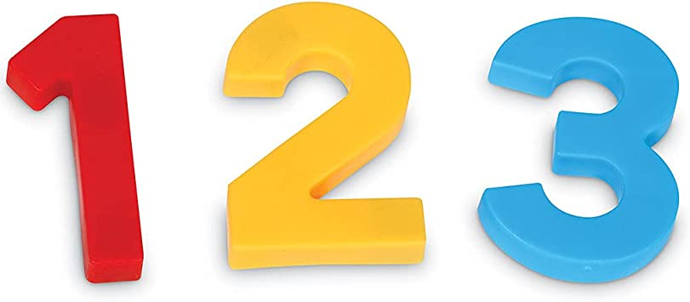
THURSDAY: NUMBER DAY !

1) Hop into the numbers

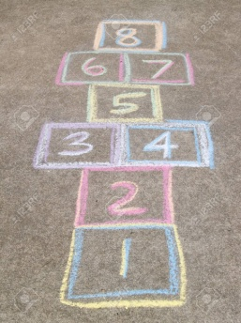
This game keeps the children active while they play and learn with different numbers.
The kids will have to count out loud every time they land on a certain number.
The teacher can make variations as she sees fit. For example:
- In number 5, you have to jump on 1 leg! - In number 3 you have to bark like a dog! ...

2) Let's do a mural together!
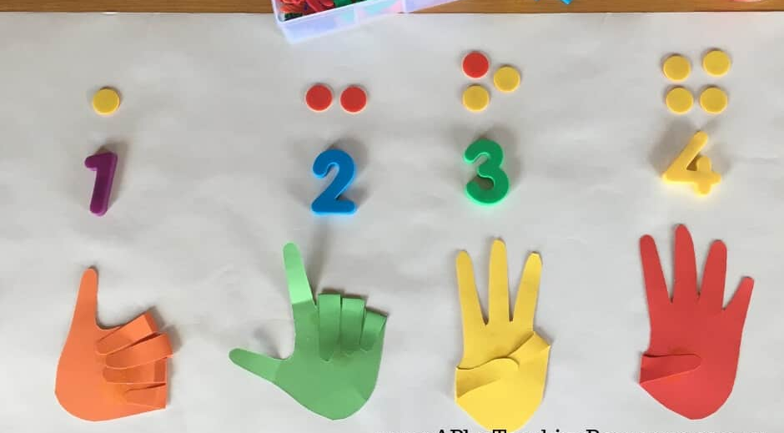
With the help of the children, we will create a mural to put in our classroom. We can use different forms to show the numbers and different colours also.

3) The puzzle number challenge
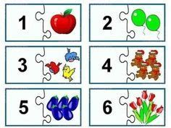
For this game the teacher will have to create a puzzle. (If there is no time, she can make the children help her too). The kids will have to find the piece that fits with the number.

4) Fill up the cup, POLE POLE
For this activity there will be an empty cup on one side of the classroom, sitting on a chair, next to a bowl/bucket of water (with a spoon inside).
The children will be on the opposite side of the class.
The teacher will say a name of one of the children, followed by a number. For example: Jhonny, Two!
After this, Jhonny will have to run to the bowl of water, fill up the spoon with water, two times, and pour them in the cup. (The teacher will supervise and assist when necessary.)
Each child will have a different number of spoonfuls to pour in the cup. The game consists of filling the cup with team work, but not letting it spill!
The child that fills to much the cup, and spills, will lose.

5) Where is the rock thief?

For this game, each coloured table will have a number written on a piece of paper. (For example, table blue, number 4, table yellow, number 6...) In each table there will be the amount of rocks the piece of paper says.
We will make sure with the children that in each table there is the correct number of stones. Then, we will take the children out of the class, while the teacher stays inside. The teacher will take out or add some rocks to each table.
The children will come back in the class and find out which tables have been altered by the thief; how many rocks are missing, or if there is more than the number there's suppose to be.
It is a good game to introduce counting, adding and reducing.

6) May the highest number win!
For this game the teacher will create a long path with different boxes:
Winner!

The children will have a different figure each, which they can identify (by colour or shape). Then, they will take turns to throw the big dice, and they're figure will move as many boxes the dice says. The figure that gets to the final box wins!
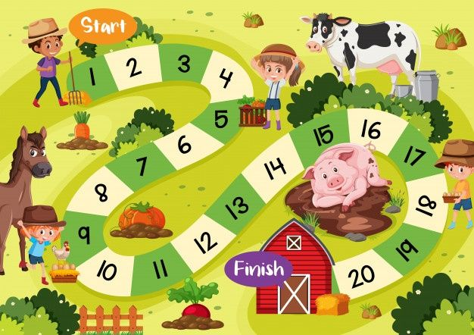

For example:

7) Create the counting caterpillar
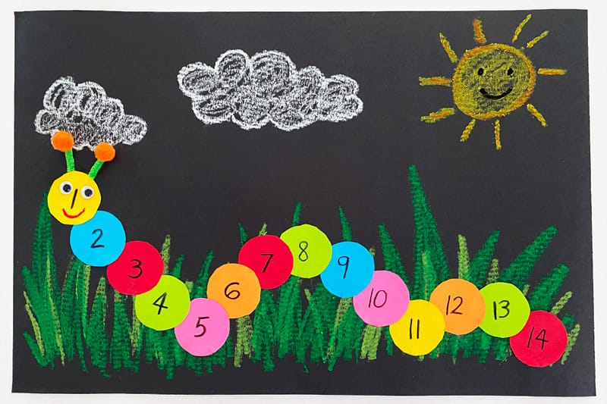
This creative craft consists of creating a colourful caterpillar with different types of materials (cotton, leafs...) and colours (Coloured paper...). Make it big, and after write the numbers on each colour, then you can hang it in the classroom!

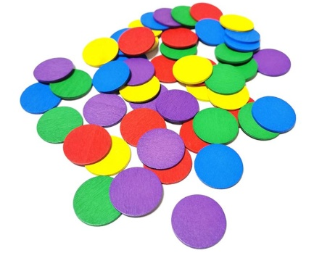
8) Scavenger hunt!
For this activity, we will use the colored round figures we have at daycare.
We will hide them around the compound (make sure you remember how many, so you don't lose any). Each child will have a bucket, and will have to go search for them individually.
After the search, the children will come back to class, and we will count how many figures does each child have. The one that has the highest number will win!

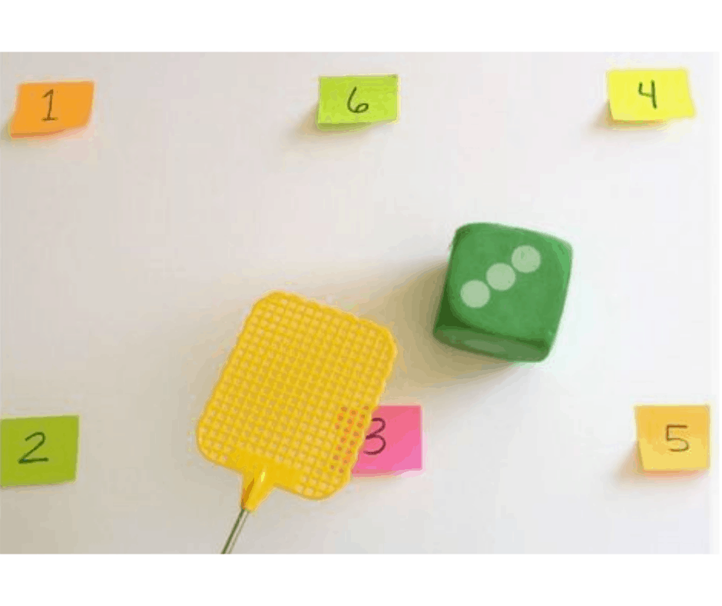
9) Swatting Numbers

For this game the children will have to toss the dice, the number of dots that comes out will have to be hit with stick or smacked with their hand fast. The children will take turns, by teachers orders and guidance.

10) Hands on numbers
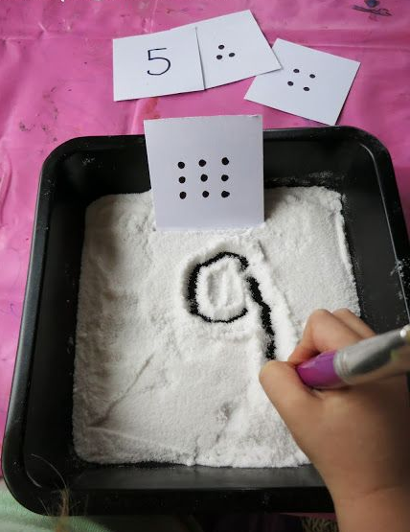
For this activity we will need some sand or salt and a tray (With a piece of paper and a little salt is also okay)
The teacher will prepare some cards with some dots on it, and each child will have to write the number of dots they can see.
The teacher can add variations, change or complicate the activity, depending on the level she looks for.

FRIDAY: MUSIC DAY!
This day is a recap day, where we dance and play with music, whilst we revise the lessons of this week! It is a fun and active way of remembering and reinforcing the information we have learnt.
PS: If there are volunteers with laptop, it is possible to connect it to the TV and watch different videos on Youtube (Cocomelon, etc.) or movies.
.

1) Musical masterpiece
Give each student a sheet of paper and color pencils.
Instruct the students to start drawing when you play the music and stop drawing when the music stops.
Leaving the paper and pens at the desk, move to another desk and continue drawing and coloring in that sheet until the music stops again.
Ask them to do so until you tell them to stop.
In the end, they go back to their desks and see the final product.

2) Musical statues... and what else?

Play the music and ask the kids to dance.

When the music stops, the children should freeze like statues.

The kids have to stand like that for a minute or so, and anyone who moves, giggles, or even wobbles when the music is not playing is out.

When the music is back on, they continue dancing.

The last person dancing on at the end is the champion statue!
- After introducing them to musical statues, the teacher can apply the lessons learnt that week:
When the music stops, go and touch color red, touch shape of a circle, touch number 3, touch body part head... !

3) Musical chairs
Set out chairs around the room (one for each player).
Play music and while it is playing, everyone dances around the room.
Remove one chair while everyone is dancing.
Stop the music every now and then and everyone must run and sit on one of the chairs.
Whoever didn’t get to a chair in time is “out”.
Repeat, removing a chair each time until there are two people left and the one who sits on the remaining chair first is the winner.

4) Match the Sounds

For this activity, you will need a variety of handmade or improvised instruments.

The objective is to listen to the music/sounds the teacher makes, and try to find appropriate instruments that match or pair well with the sound.

5) Draw the Music

In this activity children quite literally draw the music as they hear it.

Provide large pieces of paper and pencils or wax crayons and ask your children to draw what they hear.

They could draw:

How the music makes them feel, Wavy lines or zig-zags to represent slow, flowing music or fast, choppy music, the beats they hear (e.g. draw short and long lines for short and long sounds)

6) Hide and Listen

This game is about hearing the volume and making the correct associations (loud means close and soft means far).

With some handmade intruments, and the help of your children, you will be musical guides.

Blindfold your child and hide one object they know about.

Explain that when the instruments play softer he is going further from the object and when it gets louder he is getting closer to it.

6) Musical limbo

Limbo is a game that tests how flexible the body is. Add music, and it becomes all the more fun. In musical limbo, you don’t just walk under the beam. You have to go dancing from under it!

Have two adults hold the beam at a height such that the kids can pass from under it without a lot of effort.

There are two simple rules to this game: the kids have to dance to move, and they should not touch the beam.

Whoever touches the pole or fails to dance while under it is out of the game. After one round, lower the beam a little and repeat the routine.

Do it until there is only one kid left. The kid who manages to last till the end wins!

7) Dance like an animal

Put the chart of animals at a place where all the kids can see it.

You need to tell them how the animal moves, how fast or slow it moves, the sounds it makes, and any other unique traits it has.

For example, a kid who picks a dog has to be on all fours and bark in between while dancing or swaying. A snake has to crawl on the floor and a bird will flap its wings when dancing.

If need be, you could show them a few moves and get a few giggles in return.

Play the music, keep shuffling between genres, from slow to fast and vice versa. Watch the fun!

8) Nature dance/Fashion show
With the creativity of your children, you will make some nature clothes and then do a fashion show with some music over to dance too!

9) Dancing with body parts
For this game, the children will have to follow the director (Which first will be the teacher and after one of the children). If the director dances with his/her hands, only, everybody will have to do the same. (Hands, legs, head, shoulders, feet...)

10) Karaoke
For this activity, the teacher can create a fake microphone and let the children take turns to be the star!

11) Prepare for Family day show!
Tomorrow, Saturday, it is family day, what can be better than creating a special dance, song, or show to surprise everybody? Let's have some fun!

